**LA GRANDEE INTERNATIONAL COLLEGE**

**Simalchour – 8, Pokhara**

A Project Proposal

On

**SPA Appointment Booking System**

**Submitted To**

LA GRANDEE INTERNATIONAL COLLEGE

Bachelor of Computer Application (BCA) Program

*In partial fulfillment of the requirements for the degree of Program Name under*

**Pokhara University**

**Submitted By**

|  |  |  |
| --- | --- | --- |
| **Name** | **Program, Semester** | **PU Registration No.** |
| Nikhil Thapa | BCA II | 2022-1-53-0130 |
| R. A. Mohan Tiwari | BCA II | 2022-1-53-0136 |
| Prashant Sapkota | BCA II | 2022-1-53-0133 |
| Saroj Baral | BCA II | 2022-1-53-0143 |

May 2023

# Project Summary

SPA appointment booking system is a digitalized application to automate all kinds of booking activity in a SPA. The main aim of this program is to view, retrieve, book, and cancel appointments in a SPA. The system provides the staff with a user-friendly interface to view available services, book appointments, and cancel appointments.

The application is designed to be simple and easy to use, making it accessible to any authorized staff with basic computer skills. Customers can easily book their appointments as they can just call and schedule their appointments or can even visit the SPA as it wouldn’t take much time at all.

The SPA appointment system is also designed to be scalable; it can easily be adapted to meet the changing needs of the business. This system is going to be developed using Incremental Methodology which makes it easier to modify the system accordingly. The application is built using C language, which is known for its speed, efficiency, and reliability.

Overall, the SPA appointment booking system developed using C programming language is a powerful tool for SPA businesses to manage their appointments, attract new customers, and increase revenue. The system offers a convenient way for staff to book appointments, and it enables businesses to streamline their operations, reduce administrative costs, and improve customer satisfaction.

**Table of Contents**

Project Summary ii

1. Introduction 1

2. Problem Statement 2

3. Objectives 3

4. Methodology 4

4.1 Requirements: 5

4.2 Design and Development 5

4.3 Testing 5

4.4 Deployment 5

4.5 Increment 5

4.6 Final Product 5

5. Deliverables 6

6. Data Flow Diagram: 7

7. Flowchart: 9

8. Project Gantt Chart 10

9. References 11

# Introduction

Technology is a trend in today's businesses of any type. The computer is also used by many to do everything, including supporting business. Activities through desktop applications. Several types of desktop applications are available, like applications for booking systems. On the other hand, this year's personal care business is expected to grow. Everyone is interested in getting themselves relaxed after a day, a week or even after a month of work.

A SPA (Salus Per Aquam) is a facility that offers various treatments to promote relaxation, wellness, and beauty (SPA, 2023). One of the most popular treatments is massage therapy, which involves the manipulation of soft tissues to relieve muscle tension, improve circulation, and reduce stress. SPA massages may incorporate different techniques, such as Swedish, deep tissue, or hot stone, to provide a customized and rejuvenating experience.

The SPA booking system is a desktop-based application dedicated to both male and female cosmetology treatments. Massage therapists are in great demand for their services. The changes that most people experience after visiting a SPA (Salus Per Aquam) make it a patronized business.

This system connects you to the SPA with a desktop platform that allows you to browse the SPA and its services. This system helps users to review different SPAs, select one of them and make a reservation. Users may also be able to select a type of massage from the SPAs that are interested in receiving the service.

This system focuses on the appointment booking section of the SPA. Where the customers are provided with additional services according to their choice. This system helps the customer to easily view available appointments and book their appointment. It also informs the user about the length of their massage therapy and the price alongside it.

# Problem Statement

The existing appointment management system used by SPAs is often manual, time-consuming, and prone to errors, leading to customer dissatisfaction and revenue loss. The proposed SPA Appointment System application aims to provide an automated and user-friendly interface for the SPA staff to manage their customer appointments efficiently.

The problems before the proposal of this system were:

* **Time consuming and manual appointment scheduling:**

Traditional appointment booking methods involve manual scheduling, which is often time-consuming and error prone. Customers had to visit the business to book appointments, leading to long waiting times and inconvenience.

* **Difficulty in managing appointments:**

Manual appointment scheduling can be challenging to manage, especially during peak hours. Businesses may miss appointments or double-book, leading to customer dissatisfaction and revenue loss.

* **Lack of customer convenience:**

Traditional appointment booking methods do not provide customers with the convenience of booking appointments at anytime from anywhere. Customers may have to take time off from work to schedule appointments, leading to inconvenience and frustration which also leads to bad review for the SPA, noticeable reputation, and revenue loss.

* **Tension due to manual recording:**

Manual appointment booking causes tension as the record book might get lost or get damaged by accident. And it is horrendous work for the staff to check manually recorded appointments.

By developing digitalized applications for appointment booking, businesses can address these problems and provide customers with a seamless and convenient appointment booking experience. Digitalized applications can streamline appointment scheduling, reduce errors, provide quick access to customer information, and improve customer satisfaction.

# Objectives

The objective of this project is to develop a SPA Appointment System application using the C programming language to automate the process of managing appointments at a SPA.

The proposed objectives are:

* **Security:**

To ensure that only authorized staff members have access to the customer information and appointment details to maintain data privacy.

* **User registration:**

To allow the staff to register new customers by collecting their personal details such as name, contact number, and email address.

* **Appointment management:**

The staff will be able to manage customer appointments effectively by adding new appointments, canceling existing appointments, or rescheduling appointments as per the customer's request.

* **User interface:**

To provide an easy-to-use interface for the staff to manage the appointments efficiently, reduce the workload, and minimize the risk of errors.

* **Edit Price:**

To allow the authorized staff to edit the price of the available services as per the SPA’s business policy.

# Methodology

For the development of the “SPA appointment booking system” program, we’ll be using Incremental Model. Incremental methodology is a software development approach that involves breaking down a project into smaller, more manageable parts called increments. Each increment includes a defined set of features and functionalities that can be developed, tested, and deployed independently. It is a method of software development where the product is designed, implemented, and tested incrementally (a little more is added each time) until the product is finished. In the incremental model, instead of making one huge leap, we achieve our goals in small steps (JavaPoint, 2023).

FINAL PRODUCT

Fig 4.1: Incremental Model

## 4.1 Requirements:

In the requirement phase of the incremental model, the project requirements are analyzed, prioritized, and broken down into smaller, more manageable components that can be developed and tested independently in subsequent iterations.

## 4.2 Design and Development

In the design and development phase of the incremental model, each component is designed, developed, and tested iteratively, with new features and functionalities added in subsequent iterations until the final product is completed.

## 4.3 Testing

In the testing phase of the incremental model, each component is tested thoroughly to ensure that it meets the requirements and specifications. Any issues or defects are addressed and resolved before moving on to the next iteration.

## **4.4 Deployment**

In the deployment phase of the incremental model, the completed product is deployed to the end-users. Further maintenance and support are provided as necessary, with updates and new features added in subsequent iterations.

## **4.5 Increment**

In the incremental model, each iteration involves the addition of new features and functionality to the existing system, building upon the previous iteration until the final product is completed. Thus, this each iterated product is known as increment.

## 4.6 Final Product

In the incremental model, the final product is the result of multiple iterations, each adding new features and functionality. The final product meets all the requirements and specifications and is deployed to end-users.

# Deliverables

The “SPA appointment booking system” is an application that is developed to automate the process of managing appointments at a SPA.

The deliverables of the proposed system are:

* **Source Code:**

The source code of the application is written in the C programming language, including any libraries or frameworks used.

* **Database:**

A database to store appointment information, including customer information, appointment details, service provider availability, and any other relevant data.

* **Authentication System:**

An authentication system to ensure that only authorized users can book or modify appointments, including secure storage of user passwords.

* **Appointment Management System:**

A system to book, modify, or cancel appointments, with the option to view appointments.

* **Testing and Debugging:**

The system should undergo rigorous testing and debugging to ensure that it is functioning correctly and free from errors.

* **Documentation:**

Detailed documentation that explains how to use the application and how it works, including any instructions for installing and configuring the application.

* **Deployment:**

The final deliverable would be a deployed application that is ready for use by the end-users.

These are the deliverables that are to be achieved from developing a SPA Appointment Booking System using the C programming language.

# Data Flow Diagram:

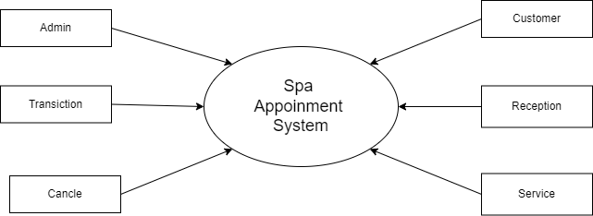

Fig 6.1: DFD 0

Fig 6.2: DFD 1

# Flowchart:

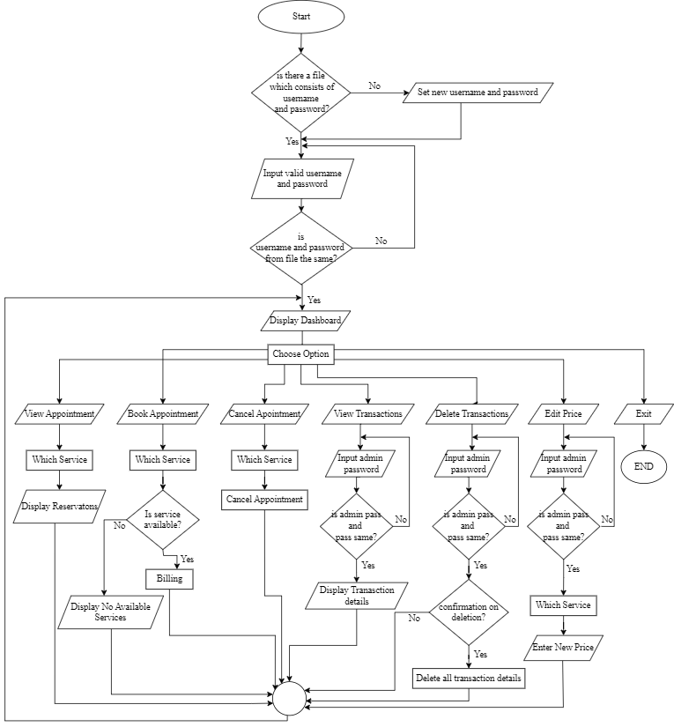

# Project Gantt Chart

# References

*JavaPoint*. (2023, 05 2). Retrieved from JavaPoint Software engineering incremental model: https://www.javatpoint.com/software-engineering-incremental-model

SPA, M. (2023, 04 29). *Malama Spa*. Retrieved from Malama Spa: https://www.malamaspa.com/